Bureau of Workers’ Compensation Payroll True-up

State of Ohio provides companies payroll frequency premiums and then we need to follow the below process annually to true-up the liability (could be credit/refund or balance owed).
Important: An employer must submit a payroll True-up report even if it has zero payroll.

What you’ll need:
- BWC True-Up Template
  - P:\Standard Operating Procedures\Excel Templates
- Client Payroll Reports
  - Need to compile annual pay reporting for the period of 07/01 – 06/30.
    - You will need Prior Year payroll data for 07/01 through 12/31
    - Pull the last payroll report (check date) in June.
      - Understand who the owner(s) are for the company. These will need separated.
      - For each owner, type their name into the excel template and their YTD gross earnings as of 06/30 prior year (column C).
      - In addition, type in the gross wages from the same paycheck (including the owners) into row 17 of the excel template which states “All Company”
    - Next, pull the last pay in December (check date).
      - Follow the same process as above, but type the wages into column D of the excel template, which is the “Last Pay Date in PY” column.
    - Lastly, pull the last June paystub (check date) in the current year
      - Follow the same process as above, but type the wages into column F of the excel template, which is the “Last Pay Date – June YTD” column.
    - Columns H & I as well as row 18 should all calculate and provide you with the necessary inputs to fill out the BWC website.

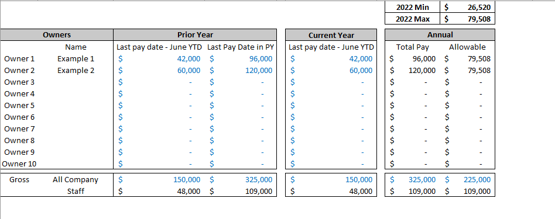

Next, open the BWC website
https://www.bwc.ohio.gov/SelfSvcAccountAdmin/secure/default.aspx

Log-in for each client using the credentials on the “Client Info USE” excel file, tab BWC

Navigate to the “Payroll True-Up” page within the BWC. The site may have you input the client’s Federal Tax ID, which can be pulled from a tax return.

Follow the prompts to fill out the return/true-up.

Save all documentation (excel as pdf, BWC confirmation & receipt) to FileCabinet under BWC subfolder.

